Final Report
Shortlisted Team Submission Template and Guidelines
All shortlisted teams submit two items: this Final Report (PDF) and a One-Minute Video (MP4). Complete every section below using the headings provided and read the Submission Requirements at the end of this document before you start writing. Replace or delete all grey guidance text before you submit.

1. Project Information
Team Registration Number | CMAT-00114
Team Name | OATSZ
Selected Theme | 1. Water Security and Sustainable Desalination
Project Title | Reducing the Environmental Impact of Desalination Brine in the UAE Through Process Optimization and Advanced Dilution
Team Leader | Muhammad owais imran
Team Leader's Email | 23623736@student.curtin.edu.au
Team Members | Muhammad owais imran – Curtin University – cybersecurity – year 1  Simone sherry – Curtin University – Mechanical engineering – year 2  Thakshinya Prakash – Curtin University - Mechanical engineering – year 1  Armeen batool – Curtin University – Cyber security – year 2
Academic Advisor(s) | Name, title, institution, email  Benita Veronica, TITLE MISSING, Curtin University, benita.veronica@curtin.edu.au
Industry Mentor(s) | Name, position, organization, email  Puzzo Simone, position missing, Ilf engineering, simone.puzzo@ilf.com  eugenia beltran, position missing, Ilf engineering, eugenia.beltran@ilf.com
One-Minute Video Link | Shareable link, viewable without sign-in
One-Sentence Solution Statement | MIZAN-02 revolutionises brine management through dual-stage passive dilution, unlocking a new pathway to dramatically expand desalination capacity while reducing the environmental burden on the Arabian Gulf.

2. Executive Summary (thaksh)
Maximum 1 page
Summarise the problem, your solution, the key result (with numbers), the expected impact, and what you need next. Write for a non-specialist reader; judges may read this section first.
[Write your response here.]

3. Problem Definition and Context (thanks and owais)
Recommended 1–1.5 pages
Define the water challenge your team addresses. Explain who is affected, where it occurs, and how large it is, supported by cited data. Explain why current approaches are not sufficient and link the problem to the relevant SDG 6 targets.
3.1 Background and Context
Desalination plays an important role in meeting freshwater demand in the United Arab Emirates (UAE), where naturally available freshwater resources are limited. Reverse osmosis and other desalination processes provide a reliable supply of potable water for households, industry and urban development. However, desalination also produces concentrated brine as a by-product. This stream contains a higher concentration of dissolved salts than the incoming seawater and must be managed appropriately before and during its discharge into the marine environment.
The environmental concern associated with brine discharge is not limited to its overall salt content. The receiving environment, discharge location, outfall configuration, local currents and mixing conditions can influence the extent and duration of elevated salinity near a discharge point. If mixing is insufficient, organisms close to the discharge may experience localized changes in salinity. The potential consequences depend on the characteristics of the receiving ecosystem and the actual conditions at the discharge site.
These concerns are relevant to the UAE because desalination facilities operate in coastal environments, including the Arabian Gulf. Developing practical approaches that improve brine dispersion could therefore contribute to more responsible desalination operations and marine environmental protection.
3.2 Problem Statement
Conventional brine discharge systems must manage the release of concentrated saline water into the surrounding marine environment. Although existing outfalls and diffusers can promote mixing, their performance depends on the design of the discharge system and the environmental conditions in which it operates. The project therefore investigates whether an additional passive mixing approach could improve the initial dilution of desalination brine without introducing unnecessary mechanical complexity.
The central problem addressed by MIZAN is the need for a potentially practical, energy-conscious method of encouraging seawater entrainment and brine mixing before the discharged stream disperses into the wider marine environment.
3.3 Project Objective and Scope
MIZAN explores a two-stage dilution concept consisting of an onshore helical static mixer and an offshore Venturi-style nozzle. The proposed static mixer is intended to promote mixing within the discharge pipeline, while the Venturi nozzle is designed to use the momentum of the primary discharge flow to encourage the entrainment of surrounding seawater.
The current development work includes CAD modelling and a physical prototype of the Venturi nozzle. The design remains subject to further engineering analysis and validation. The project's objective is to investigate the feasibility of this approach, rather than to claim that environmental benefits or improved dilution have already been demonstrated.

4. State of the Art and Gap
Recommended 1–1.5 pages
Review existing technologies, products, practices, or policies. Compare the main alternatives in a short table (performance, cost, maturity, limitations) and state clearly the gap your solution fills.

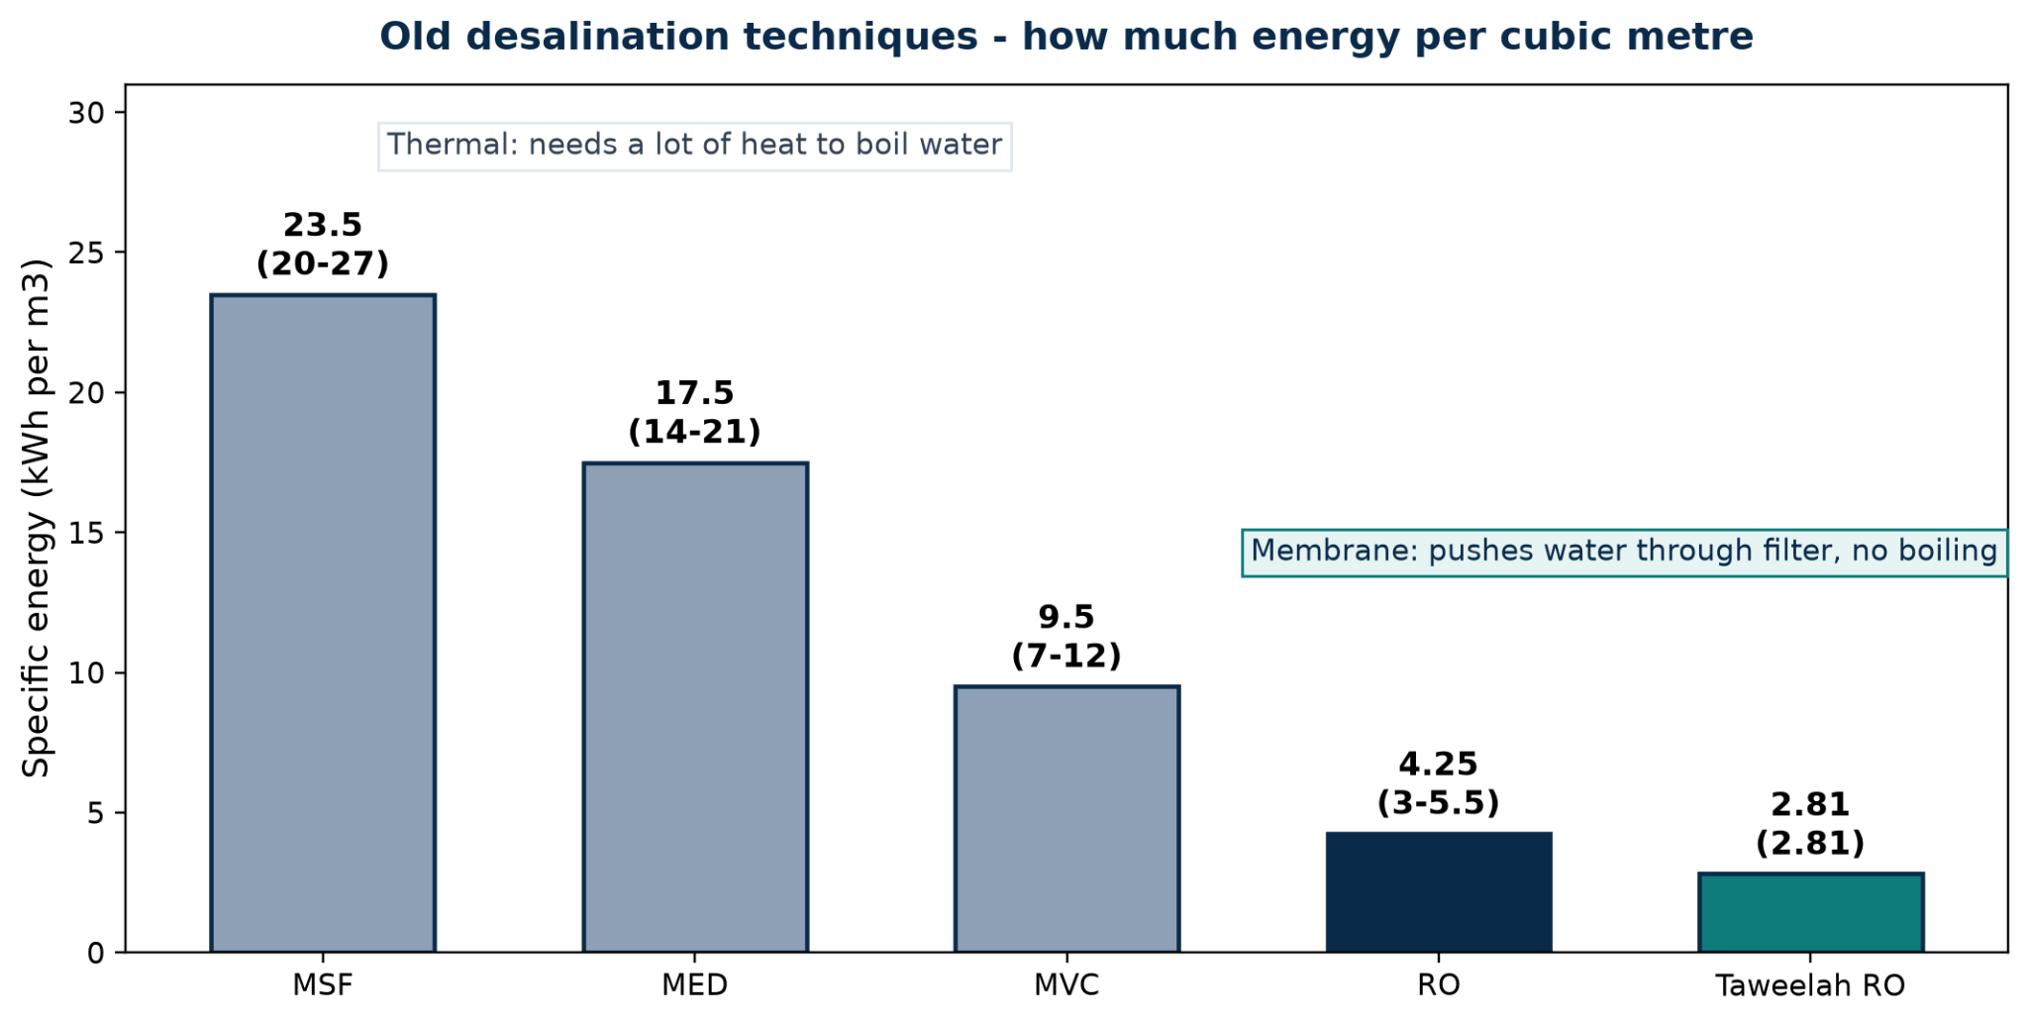
Desalination in the Arabian Gulf has historically been closely integrated with power generation. Thermal technologies such as Multi-Stage Flash (MSF) and Multi-Effect Distillation (MED) made use of shared infrastructure and available waste heat, allowing freshwater production alongside electricity generation.
MSF typically consumes approximately 20–27 kWh/m³ of thermal energy, while MED operates at approximately 14–21 kWh/m³. Vapour compression offers a lower thermal-energy requirement of approximately 7–12 kWh/m³. These processes rely on repeated evaporation and condensation, making their energy requirements fundamentally different from membrane-based desalination.
Figure 1: Specific energy of established desalination options (kWh per m3 product water). Ranges are literature-reported context, Taweelah RO is a reported plant figure to be verified — see Section 6.
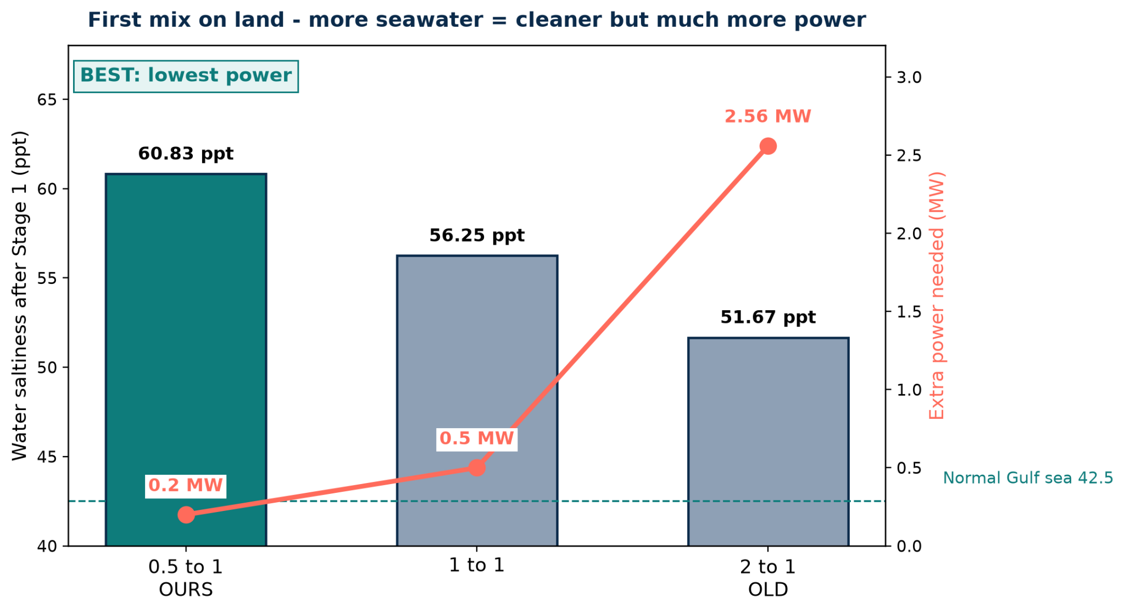
The transition towards standalone seawater reverse osmosis (SWRO) has changed this landscape. By using pressure-driven membranes rather than thermal evaporation, SWRO can substantially reduce energy consumption, with typical reported figures of approximately 3–5.5 kWh/m³.
This transition, however, introduces another engineering consideration: brine management. Modern RO facilities cannot automatically rely on the large cooling-water flows associated with older integrated power and desalination plants.

Figure 2: Onshore pre-dilution trade-off for the 2-m example (CALCULATED, ESTIMATED ±30–50%). Bars = salinity after Stage 1, line = extra power. Dashed = Gulf 42.5 pp

Table 2. Beyond desalination energy consumption, the management of concentrated brine presents a separate engineering challenge. Existing approaches range from conventional offshore diffuser systems to additional onshore dilution, passive hydraulic entrainment and intensive brine treatment. These alternatives differ considerably in energy requirements, infrastructure demands and technological maturity. Table 1 compares five approaches using a common reference brine flow to evaluate their relative engineering and operational requirements.
Option | What it does | Extra power, ref. case (MW) | Extra energy per m³ brine (kWh/m³) | Electricity cost per m³ brine (AED) | Maturity | Key limitation
A. Long pipe + diffuser | Fast jets far offshore | 0.28 | 0.012 | 0.005 | Proven, widely used | Needs depth; kilometres of pipe; fails in 5–12 m shallows
B. Onshore dilution (2:1) | Pumped seawater pre-mix | 2.56 (up to 5.12 in undersized pipe) | 0.113 (up to 0.226) | 0.050 (up to 0.100) | Proven (Spain) | Pumps >1M m³/day extra water; needs ≥3.1 m pipe
C. Venturi alone | Jet entrains seawater passively | 0.29 | 0.013 | 0.006 | Pilot stage | Needs ~11 m/s precedent; only reaches ~56 ppt; clogging
D. ZLD | Evaporate all, recover solids | 158–792 | 7–35 | 3.08–15.40 | Industrial, not SWRO-proven | 10–100× the energy; heat dominates cost
E. MIZAN-02: 0.5:1 pre-dilution + eductor | Onshore pre-dilution + passive offshore seawater entrainment | 0.43 | 0.019 | 0.0084 | Lab + prototype | Needs 7–8 m head; screens + cleaning

Basis: 542,851 m³/day brine (~393,200 m³/day product at 42% recovery), AED 0.44/kWh. Multiply per-m³-brine figures by 1.38 for per-m³-product basis. ZLD range from O'Connell et al. (2024); 11 m/s from the Maspalomas pilot (to be verified); Spanish percentages are reported operating figures, site-dependent. Team values (B, C, E) are ESTIMATED ±30–50%; see Section 6.

Identified Engineering Gap

The comparison highlights a gap between conventional offshore discharge systems and energy-intensive pre-treatment approaches. Existing diffusers rely heavily on suitable offshore conditions, while extensive onshore dilution requires substantial additional seawater pumping. Standalone Venturi systems offer passive entrainment but depend on sufficient hydraulic head and carefully optimised nozzle geometry.
MIZAN-02 proposes combining these approaches into a single two-stage configuration. Initial onshore pre-dilution reduces the brine salinity, while an offshore passive eductor uses the hydraulic energy of the discharge to entrain additional ambient seawater. The reference design uses a 0.5:1 seawater-to-brine dilution ratio during onshore pre-dilution, with a preliminary estimated additional power requirement of 0.43 MW for the combined system. The proposed innovation lies in distributing dilution across two stages rather than relying entirely on additional mechanical pumping or post-discharge dispersion. This creates a potential pathway for adapting existing desalination infrastructure to improve brine management, particularly at sites where shallow bathymetry and limited coastal circulation constrain conventional discharge arrangements.

5. Proposed Solution
Recommended 2–3 pages
Describe your solution and how it works, including a system or concept diagram. Explain your key design choices and what is new. If you developed a prototype, simulation model, AI tool, or digital platform, describe it here and provide an access link (repository, demo, or dataset).
5.1 System Overview
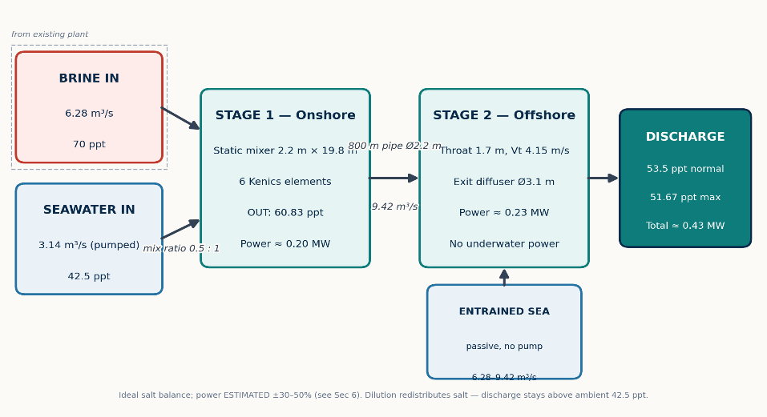
MIZAN Dual-Draft conditions brine for discharge in two passive stages with no underwater machinery (Figure 3). Brine (6.283 m³/s at 70 ppt) first meets a small pumped seawater stream (3.142 m³/s at 42.5 ppt, ratio 0.5:1) in an onshore static mixer, leaving at 60.83 ppt. This flow travels 800 m offshore through a 2.2 m pipe and accelerates through a 1.7 m Venturi throat, whose suction entrains ambient seawater through circumferential intakes — 6.28 m³/s in normal operation, 9.42 m³/s at maximum dilution — with no pump, motor or cable underwater. A 3.1 m diffuser then slows the mixture for discharge at 53.5 ppt normal or 51.67 ppt maximum, for a system total of about 0.43 MW. The design is a retrofit cap for existing outfalls: the plant's process is untouched; only the discharge path is re-engineered.
Figure 3: MIZAN-02 dual-stage system: onshore static mixing (0.5:1, 70 → 60.83 ppt, ~0.20 MW) plus offshore passive entrainment to 53.5 ppt normal / 51.67 ppt maximum (~0.23 MW more). Reference-case flows; CALCULATED mixing, ESTIMATED power (see Section 6).
5.2 Stage One: Onshore Static Mixing
Stage 1 uses a Kenics-type helical static mixer: six 180° twisted ribbons of alternating handedness, each rotated 90° to the last, housed in a 2.2 m × 19.8 m pipe section (L/D 9). Seawater is injected at the wall immediately before the first element so the highest-shear zone does the work. Each element splits the combined stream and rotates the halves through 180°, doubling the number of brine/seawater striations per element until molecular diffusion completes blending — uniformity (CoV < 0.05 target) with no moving parts, for about 0.17 m of head loss, this has been verified by running CFD simulations of the internal mixing structure.
The 0.5:1 ratio is deliberate, not arbitrary. As Figure 2 shows, salinity falls slowly while power rises steeply: doubling dilution water from 0.5:1 to 2:1 buys only ~9 ppt (60.83 to 51.67) but multiplies extra power from 0.20 to 2.56 MW and demands over a million cubic metres per day of additional pumping plus a 3.1 m pipe to stay under erosion limits. MIZAN therefore takes only the cheap first increment onshore — where each kilowatt buys the most dilution — and leaves the rest to Stage 2, whose water costs no pumping energy at all.
5.3 Stage Two: Offshore Passive Eduction
Stage 2 sits at the outfall terminus, so the long pipe carries only 9.42 m³/s instead of 18.84 m³/s — saving roughly 6 m of friction head compared with placing a Venturi onshore. The primary flow accelerates from 2.48 m/s to about 4.15 m/s in the 1.7 m throat; the resulting suction draws ambient seawater through 360° intake slots and the streams combine in an 11.9–15.3 m mixing tube (7–9 throat diameters) before a 3.1 m diffuser slows the mixture to 2.5 m/s for release.
Entrainment ratio w (sucked flow ÷ primary flow) sets the endpoint: w = 0.33 gives 56.25 ppt, w = 0.67 gives 53.5 ppt, and w = 1.0 gives 51.67 ppt. The diffuser-exit mixture for the 53.5 / 51.67 cases will be shown by the planned eductor CFD (Section 6.4); Figure 5 shows the mixer stage that is complete. Because power barely changes across this range (0.20–0.23 MW) while intake area doubles (2.09 to 6.28 m²), the operating point is chosen on fouling and cleaning grounds: 53.5 ppt normal operation with throttled intakes, 51.67 ppt maximum when currents are weak or corals are spawning.
5.4 Engineering Design Choices
Geometry follows two hard constraints: pipe velocity below 3.0 m/s to control erosion, and intake face velocity below 0.15 m/s for fish protection (Table 2). Forcing the full mixed flow through one 2-m pipe would run at 6.0 m/s and fail the first rule — hence the correctly sized 2.2 m approach and 3.1 m exit. The 1.7 m throat is the calculated sweet spot: a 1.5 m throat gives more suction but approaches erosive velocity (5.56 m/s), while 1.0 m (8.0 m/s) and 0.8 m (12.5 m/s, cavitation risk) were rejected. The system needs 7–8 m of booster head on the primary flow; if the plant cannot provide it, a ~0.5 MW booster pump is included in the capital plan rather than assumed away. Screens are sized at five times the throat window area so the face velocity stays below the fish-protection limit even at maximum entrainment, with removable panels for diver or ROV cleaning — biofouling halving the open area is carried as a performance case, not an afterthought (Section 7).
Table 2. MIZAN reference geometry and function. Dimensions are team design values; offshore length and site conditions are ASSUMED examples pending plant data.
Component | Key dimensions | Function | Status
Static mixer | 2.2 m ID × 19.8 m; 6 × Kenics 180° elements | 0.5:1 seawater-to-brine blending to 60.83 ppt | CAD complete; CFD performed (Section 6), prototype printed.
Offshore pipe | 800 m; 2.2 m ID (example) | Transport at 9.42 m³/s | ASSUMED — site-specific confirmation required
Venturi throat | 1.7 m ID; Vt ≈ 4.15 m/s | Drive entrainment ratio w = 0.33–1.0 | CAD complete; CFD Pending
Mixing tube | 11.9–15.3 m (7–9D) | Combine and homogenise entrained seawater | Straight pipe section; — site-specific confirmation required
Diffuser exit | 3.1 m ID; Ve ≈ 2.5 m/s | Discharge at 53.5 / 51.67 ppt | CAD Pending
Intakes + screens | 2.09–6.28 m²; face velocity < 0.15 m/s | Passive seawater intake and debris protection | PROPOSED; cleaning plan required
5.5 Innovation and Integration
Conventional options each pay full price for dilution: long outfalls buy it with kilometres of pipe, onshore pre-dilution with megawatts of pumping, Venturi-only designs with extreme jet velocities that still stall near 56 ppt, and ZLD with an order of magnitude more energy (Table 1). MIZAN's novelty is the split — a small pumped pre-mix where each kilowatt buys the most dilution, plus a momentum-driven offshore stage whose water is free — packaged as a retrofit cap that leaves the desalination process untouched. To our knowledge, no Gulf mega-plant has published a two-stage passive retrofit of this form (search scope: English-language desalination and outfall literature to October 2026; absolute novelty not claimed).
Integration needs no new land: the mixer inserts into the existing discharge line, the eductor bolts to the outfall terminus, and screens mount on standard frames. Scale-up is by parallel trains, not redesign — one train handles ~9.4 m³/s intermediate flow, so Taweelah-scale flow (~2.3× the reference) takes two to three identical trains, and turndown is handled by isolating a train so the rest keep full mixing velocity at part load.
5.6 Prototype and Development Status
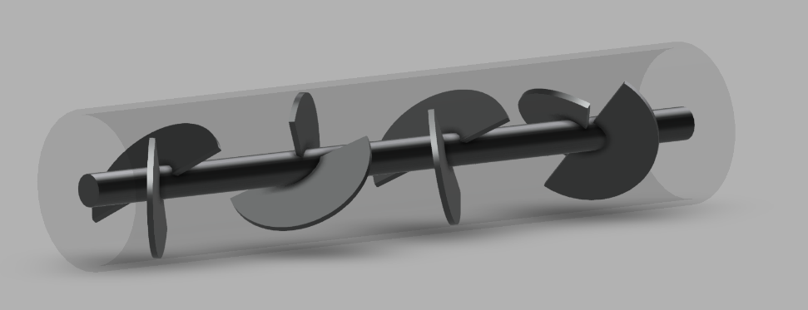
Geometry is complete: parametric Blender models of the six-element mixer (25 mm lab bore) and the Venturi eductor (40–85 mm lab throats) with STL export, plus the full-scale reference dimensions in Table 2 (Figure 4). Team CFD of the static-mixer stage is complete; setup, mesh and boundary conditions are documented in Section 6 and Appendix B, with contour results in Figure 5. No physical experiments have been run yet — printing the lab rig and tank-testing entrainment, head loss and uniformity against the Section 6 criteria is the funded next step.
Figure 4: Laboratory-scale static mixer (25 mm bore, 5 helical elements) modelled for 3D printing.
Repository (CAD scripts, STL files, CFD case files, calculation sheets):

6. Methodology and Validation (owais simone)
Recommended 3–4 pages
Explain how you developed and tested the solution: experiments, simulations, models, data sources, AI training data or pilot work. State assumptions, parameters, and controls. Present results with numbered figures and tables, including uncertainty or ranges. State the current Technology Readiness Level (TRL) and the target TRL. Label any simulated or estimated results clearly.
[Write your response here.]

7. Feasibility and Scalability (armeen and thakshinya mentoring)
Recommended 1.5–2 pages
Estimate capital and operating costs (USD or AED, per m³ or per user where relevant), energy use, materials and maintenance needs. Describe the scale-up pathway from laboratory or pilot to full deployment, and list the main technical, financial and operational risks with mitigation measures.
7.1 Technical Feasibility
The MIZAN Dual-Draft Hybrid combines onshore seawater pre-dilution with an offshore passive eductor to dilute desalination brine while potentially reducing pumping requirements. The reference design assumes a brine flow of 542,851 m³/day at 70 ppt salinity, with ambient seawater at 42.5 ppt. Adding seawater onshore is estimated to reduce salinity to 60.83 ppt, followed by offshore entrainment to approximately 53.5 ppt under normal operation or 51.67 ppt under higher dilution.
These values are preliminary calculations, not experimentally verified results. Dilution redistributes salt rather than removing it, so the discharge remains more saline than ambient seawater. Feasibility depends on eductor performance, available pressure, currents, corrosion, erosion and fouling. Computational fluid dynamics (CFD) and pilot testing are required before deployment (Al-Saidi et al., 2023).
7.2 Preliminary Energy and Cost
The reference system has an estimated power demand of 0.43 MW. Assuming continuous operation and an illustrative electricity tariff of AED 0.44/kWh:
- Daily energy: 430 kW × 24 h = 10,320 kWh/day.
- Daily cost: 10,320 × AED 0.44 = AED 4,540.80.
- Annual energy: 430 kW × 8,760 h = 3.77 GWh/year.
- Annual cost: 3,766,800 kWh × AED 0.44 = AED 1.66 million.
- Energy and electricity cost per m³ of brine: 10,320 ÷ 542,851 ≈ 0.019 kWh/m³, equivalent to approximately AED 0.0084/m³ for electricity only.
These estimates exclude capital costs, maintenance, downtime and any additional booster pump. A fair comparison with conventional discharge systems must account for the same flow, dilution target and complete system costs (O’Connell et al., 2024).
7.3 UAE Case Study: Taweelah RO Plant
Taweelah in Abu Dhabi has a reported capacity of 200 million imperial gallons per day, approximately 909,200 m³/day of product water. ACWA Power reports a project cost of US$907 million and commercial operation beginning in Q1 2024. Its Environmental and Social Impact Assessment (ESIA) provides information relevant to evaluating discharge and environmental management (ACWA Power, n.d.).
Illustrative brine-flow estimate: Taweelah’s actual brine flow is not established by its product-water capacity alone. Assuming a 42% recovery rate:
Feed flow = Product flow ÷ Recovery rate
Feed flow = 909,200 ÷ 0.42 ≈ 2,164,762 m³/day.
Brine flow = Feed flow − Product flow
Brine flow = 2,164,762 − 909,200 ≈ 1.26 million m³/day.
This is an illustrative estimate, not verified plant data.
Potential MIZAN application: The existing discharge pipeline and outfall could be assessed for integration with an onshore mixing stage and offshore eductor. The plant’s actual brine flow, salinity, pipeline geometry, available pressure, bathymetry and currents must first be obtained. CFD and a site-specific pilot would then test mixing performance, pressure losses and marine plume behaviour.
Illustrative daily electricity cost at Taweelah scale:
Scale factor = Estimated Taweelah brine flow ÷ Reference brine flow
Scale factor = 1,255,562 ÷ 542,851 ≈ 2.31.
Estimated power = 0.43 MW × 2.31 ≈ 0.99 MW.
Daily cost = 0.99 MW × 1,000 × 24 h × AED 0.44/kWh ≈ AED 10,500/day.
Annual cost = AED 10,500 × 365 ≈ AED 3.83 million/year.
This assumes linear scaling and continuous operation. It is not Taweelah’s actual operating cost; real performance and costs require plant-specific engineering data and testing.
7.4 Costs, Scalability and Risk Management
Capital costs include the eductor, pipeline modifications, seawater intake and screens, instrumentation, marine installation, modelling and environmental approvals. Duplex stainless steel and other seawater-resistant materials could be evaluated for corrosion and erosion resistance. A reliable capital-cost estimate requires final design specifications and supplier quotations.
Implementation should proceed in stages: (1) CFD and hydraulic modelling; (2) laboratory testing of entrainment, pressure and energy use; (3) a site-specific pilot; and (4) independent environmental and economic evaluation before any full-scale decision.
Key risks include insufficient entrainment, higher-than-expected energy demand, corrosion, fouling, intake impacts on marine organisms and unacceptable salinity plumes. Mitigations include testing under realistic conditions, routine inspection, suitable materials, intake protection and monitoring salinity at multiple distances from the outfall. Site-specific ecological assessment is particularly important in the Persian Gulf (Sharifinia et al., 2019).
Routine maintenance would include cleaning intake screens, inspecting the eductor and pipelines for corrosion or erosion, calibrating sensors and replacing worn components.
7.5 Feasibility Conclusion
MIZAN offers a potentially scalable method of improving initial brine mixing, with preliminary reference energy costs of approximately AED 4,541/day. A simplified Taweelah scale-up suggests approximately AED 10,500/day, based on an assumed recovery rate and linear scaling. Neither estimate is experimentally verified. Further modelling, pilot testing, verified plant data and lifecycle-cost analysis are necessary before claiming economic savings or environmental compliance.

8. UN-Aligned Impact and Policy Brief (armeen)
Recommended 1.5–2 pages
Explain how the solution contributes to the UN Water pillars and SDG 6, and to any related goals (e.g., SDG 3, 7, 11, 13, 14). Describe the expected environmental, social, health, and economic benefits with measurable indicators. Provide policy or governance recommendations that would support adoption.
8.1 Alignment with UN-Water and Sustainable Development Goals
MIZAN supports SDG 6 (Clean Water and Sanitation) by proposing improved management of concentrated brine from seawater reverse osmosis (SWRO) desalination. This is particularly relevant to the UAE, where desalination is essential for water security. MIZAN aims to improve brine dilution before discharge, potentially reducing localised high-salinity exposure.
The project aligns with the five accelerators of UN-Water's SDG 6 Global Acceleration Framework (UN-Water, 2020):
- Innovation: Combines onshore pre-dilution with an offshore passive eductor.
- Data and information: Uses CFD modelling, salinity measurements and marine monitoring.
- Capacity development: Encourages collaboration between engineers, researchers and desalination operators.
- Financing: Requires assessment of energy, maintenance and lifecycle costs.
- Governance: Promotes cooperation between industry and environmental authorities.
MIZAN may also contribute to SDG 6.3 (improving water quality) and SDG 6.6 (protecting water-related ecosystems). Its wider relevance includes SDG 3 through indirect protection of coastal environmental quality; SDG 7 and SDG 13 through the potential reduction of pumping energy and associated emissions; SDG 11 through more sustainable water infrastructure; and SDG 14 through improved management of brine discharge and protection of marine ecosystems (United Nations, n.d.).
8.2 Expected Environmental, Social, Health and Economic Impact
MIZAN's main expected environmental benefit is improved mixing of concentrated brine before marine discharge. Reference calculations estimate a reduction from 70 ppt to 60.83 ppt after pre-dilution, followed by approximately 53.5 ppt under normal operation or 51.67 ppt under higher dilution. These figures are theoretical and require testing. Since the discharge remains saltier than ambient seawater, MIZAN does not eliminate brine pollution.
Environmental performance should be measured through discharge salinity, plume dispersion, salinity at different distances from the outfall, local currents and marine-life observations. Intake impacts on marine organisms should also be monitored.
Socially, MIZAN could support more sustainable desalination infrastructure and long-term water security for coastal communities. Its indirect health contribution relates to protecting coastal environmental quality, rather than providing a direct health benefit.
Economically, the passive eductor may reduce additional mechanical pumping. The reference design estimates 0.43 MW of power demand, or approximately 0.019 kWh per m³ of brine. At the assumed electricity tariff, this equals AED 0.0084/m³ for electricity alone. These estimates require validation and exclude maintenance, installation and other operating costs. Key economic indicators should include energy consumption, electricity cost, maintenance expenses and total lifecycle cost.
8.3 Policy and Governance Recommendations
The following measures would support responsible adoption:
- Environmental assessment: Require site-specific environmental assessments covering brine dispersion, marine biodiversity and intake impacts.
- Pilot testing: Require laboratory and site-specific trials, with independent verification of dilution, energy use and environmental performance before full-scale deployment.
- Continuous monitoring: Monitor discharge salinity, plume behaviour and marine conditions, reporting results to relevant authorities.
- Industry collaboration: Encourage partnerships between desalination operators, universities, technology developers and government authorities to improve designs and local expertise.
- Lifecycle-cost evaluation: Include capital, electricity, maintenance, cleaning, replacement and environmental monitoring costs in investment decisions.
8.4 Overall Impact
MIZAN could support more sustainable desalination, particularly SDG 6 and SDG 14, through improved brine management and marine protection. However, adoption should depend on verified performance, acceptable environmental impacts and demonstrated economic feasibility.

9. Industry-Adoption Roadmap (simon e owais)
Recommended 1–1.5 pages
Identify target users, customers and partners, and the business or delivery model. Outline regulatory, certification, or approval steps, and present a milestone timeline for the next 12–36 months.

10. Team Contributions, Mentoring and Ethics (thanks )
Recommended 0.5 page
State each member’s contribution and the input received from your academic advisor and industry mentor. Note any ethics, safety or data-protection approvals, and disclose where and how generative AI tools were used.
[Write your response here.]

11. Conclusions and Next Steps (whole team and takshno)
Recommended 0.5 page
Summarise the main findings and the limitations of your work, and explain how you would develop the solution further, including how prize funding and mentoring would be used.
[Write your response here.]

12. References (everyone)
Section 7:
ACWA Power. (n.d.). Taweelah RO desalination IWP. https://acwapower.com/en/what-we-do/projects/taweelah-ro-desalination-iwp/
ACWA Power. (2019). Taweelah IWP environmental and social impact assessment: Volume 2. https://acwapower.com/media/kudjbtxa/al-taweelah-iwp-esia-volume-2.pdf
Al-Saidi, M., Saadaoui, I., & Ben-Hamadou, R. (2023). Governing desalination, managing the brine: A review and systematization of regulatory and socio-technical issues. Water Resources and Industry, 30, 100225. https://doi.org/10.1016/j.wri.2023.100225
O’Connell, M. G., et al. (2024). Analysis of energy, water, land and cost implications of zero and minimal liquid discharge desalination technologies. Nature Water, 2, 1116–1127. https://doi.org/10.1038/s44221-024-00327-1
Sharifinia, M., et al. (2019). Prevention is better than cure: Persian Gulf biodiversity vulnerability to the impacts of desalination plants. Global Change Biology, 25(12), 4022–4033. https://doi.org/10.1111/gcb.14808

13. Appendices (Optional)
Maximum 10 pages · not counted in the page limit
Include supporting material only: additional data, detailed calculations, code or model documentation, and letters of support. Judges are not required to read the appendices, so keep all essential content in the main report.
null

14. Team Leader and Academic Advisor Declaration
We confirm that the information in this Final Report and the One-Minute Video is accurate and is the original work of the team; that all sources, data and tools, including any generative AI tools, have been acknowledged; that everyone appearing in the video has consented to its publication; and that the academic advisor has reviewed this submission.
Team Leader's Name: Muhammad owais imran
Signature: Signed owais imran
Date: 30/10/2026
Academic Advisor's Name:
Signature:
Date:

Submission Requirements
Read these requirements carefully. Submissions that are late, incomplete or exceed the hard limits below may not be evaluated.

A. Key Dates
Milestone | Date | Details
Final Report and One-Minute Video due | 1 November 2026, 23:59 (UAE time, GMT+4) | Both items submitted together by the team leader
Finalists announced | 6 November 2026 | Finalist teams are notified by email
Finals and awards ceremony | 8–10 December 2026 | On-site showcasing in Abu Dhabi during the UN Water Conference

B. Final Report Format
Element | Requirement
Length | Maximum 15 pages for Sections 2–11. Project Information, References, Appendices and Declaration are not counted. Pages beyond the limit will not be read.
Page layout | A4, portrait, 2.5 cm margins; use this template without changing its headings or order
Font and spacing | Calibri 11 pt body text, 1.15 line spacing; headings as provided in this template
Language | English, with consistent spelling throughout
Figures and tables | Numbered and captioned (Figure 1, Table 1), legible when printed, and cited when not your own
Units and equations | SI units; equations numbered with all symbols defined at first use
Headers and footers | Keep the hackathon header; add page numbers in the footer
File format | One text-searchable PDF (not scanned), fonts embedded, maximum 10 MB

C. One-Minute Video Requirements
Element | Requirement
Duration | Maximum 60 seconds, including titles and credits. Content after 1:00 will not be considered.
Technical format | MP4 (H.264), 1920 × 1080 pixels, 16:9 landscape, maximum 100 MB
Language and subtitles | English narration or English subtitles; burned-in English subtitles are required so the video can be understood without sound
Opening and closing | Open with a title card (project title, team registration number, theme); close with team name, universities and credits
Team presence | At least one team member must appear on camera or narrate
Content and rights | Original footage, animations or screen recordings only; any music or images must be royalty-free or licensed and credited
Logos and consent | Do not use Khalifa University, UNESCO or UN logos unless provided by the organizers. Everyone shown must consent to publication.
Use of the video | The video may be screened at the finals and shared on organizer channels

Recommended storyboard
Time | Segment | What to show
0:00–0:05 | Title and hook | Title card and one striking fact about the problem
0:05–0:15 | The problem | Who is affected, where, and how much – one key number
0:15–0:35 | The solution | What it is and how it works: prototype, model, app demonstration or animation
0:35–0:48 | The evidence | Your key result and how it compares with current options
0:48–0:56 | Impact and scale | Contribution to SDG 6 and the UN Water pillars; who will adopt it next
0:56–1:00 | Close | Team name, universities, call to action and credits

D. Evaluation Criteria
The Final Report and One-Minute Video are evaluated together by the technical review panels, the UN/policy relevance panel and the grand jury, using the official hackathon criteria:
Criterion | Weight | Main evidence
Scientific and technical rigor | 30% | Sections 4–6
Alignment with UN Water pillars | 20% | Section 8 and the video
Feasibility and scalability | 20% | Section 7
Industry relevance and adoption potential | 15% | Section 9
Quality of communication and presentation | 15% | Whole report and the video

E. How to Submit
- Submit the Final Report as a PDF and include the One-Minute Video through the Google Form.
- Make sure the uploaded video file (MP4) can be viewed and keep it available until 31 December 2026.
- Deadline is 1 November 2026, 23:59 (UAE time). The last submission received before the deadline will be evaluated.
Name the files as follows:
Registration Number_Theme Number_Team Leader Name_Final Report.pdf
Registration Number_Theme Number_Team Leader Name_Video.mp4

F. Final Checklist
☐ All sections (1–14) are completed using the template headings, and all grey guidance text is removed.
☐ Sections 2–11 do not exceed 15 pages; appendices do not exceed 10 pages.
☐ Team registration number, all team members, academic advisor, and industry mentor are listed.
☐ Figures and tables are numbered, captioned and cited; all sources are referenced.
☐ The report is a searchable PDF under 10 MB and named correctly.
☐ The video is 60 seconds or less, MP4 1080p, under 100 MB, with English subtitles.
☐ The video link opens without sign-in, and the report and video use the same title and key figures.
☐ Use of generative AI tools is disclosed in Section 10.
☐ The declaration is signed by the team leader and the academic advisor.

